**Problem statement:**

We have the 10 years of data for the gold stock on the daily basis. We need to predict the stocks prize for the next 1 month.

Below link was used to get the data for the model.

<https://finance.yahoo.com/quote/GC%3DF/history?period1=1293840000&period2=1591747200&interval=1d&filter=history&frequency=1d>

**Scope of the model:**

Using some advance deep learning techniques which using recurrent neural networks to predict the more accurate predictions.

The technique which used in model building is LSTM.

For tuning of the parameters we tried various combinations which best fits to the data.

Combinations:

With/Without Relu activation function.

With/Without Sigmoid activation function.

With single/double/triple hidden layers.

Model comparisons:

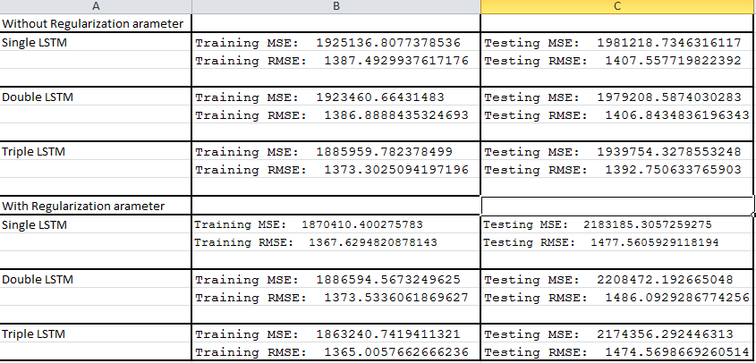

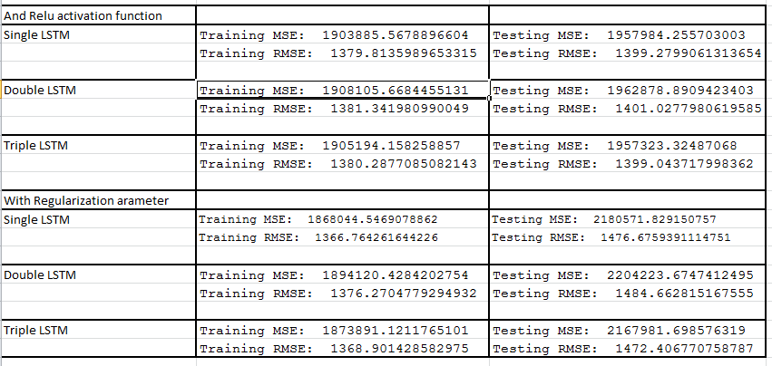

Conclusion:

As per above RMSE/MSE comparison we can conclude that the model which is best fit for our data is Triple LSTM without regularization parameter.